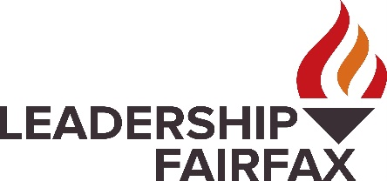
Leadership Fairfax Names New CEO
Fairfax native Kia Cole-Hines brings history of mentoring and community engagement to Northern Virginia’s premier leadership program.

September 25, 2023

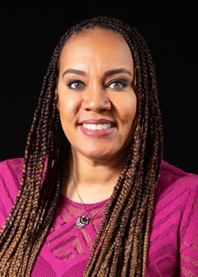
Leadership Fairfax is pleased to announce the appointment of Kia Cole-Hines as its next President and Chief Executive Officer.

“We are thrilled to welcome Kia to the Leadership Fairfax family,” said Dominic Bonaiuto, chair of the Leadership Fairfax Board of Directors. “Her passion for our community is clear to anyone who spends time with her, and she has compelling experience as a leader, collaborator, and mentor, the values on which LFI is founded.”
Kia Cole-Hines
President & CEO
Leadership Fairfax, Inc.
Cole-Hines succeeds Karen Cleveland, who has led the organization for the past eight years, and her selection follows a months-long search conducted by the Leadership Fairfax Board of Directors that attracted a robust and talented slate of candidates.

“We express our heartfelt gratitude to Karen, who helped Leadership Fairfax flourish during her tenure and put us in a strong position for this transition,” Bonaiuto continued. “With this passing of the torch, we are confident that Kia will ensure LFI continues to be a guiding light for building and sustaining an inclusive, equitable, and connected community in which everyone can thrive.”

Most recently, Cole-Hines was Executive Director for the Friends of Reston, the nonprofit organization supporting Reston Association with scientific, educational, and charitable programming. She took over that role just prior to the pandemic, yet successfully managed to build new community engagement, strengthen management, and expand fund raising opportunities.

“I truly believe that my background, experience, and skillset align perfectly for this opportunity, and I am extremely excited to join the Leadership Fairfax family,” Cole-Hines said. “I have lived, learned, and led in this community, so this is more than just a job. It is extremely personal as it allows me to have a hand in cultivating the next generation of leaders for our community as we prepare to write the next chapter of our great success story.”

In addition to her duties with Friends of Reston, Cole-Hines also serves as Reston Association’s Business Engagement and Sales Manager. Prior to her current role she held management, business development, financial, recruitment, and marketing positions within the personal services and pharmaceutical fields. She also served as a career and college counselor within Fairfax County Public Schools.

Cole-Hines also sports an impressive athletics resume. She played basketball and field hockey at South Lakes High School and went on to play basketball at St. John’s University, where she was an Academic All-American. Prior to taking on her executive roles, she spent time coaching at the collegiate level, including at George Mason University. In 2016, she was inducted into the South Lakes High School Hall of Fame.

She takes over Leadership Fairfax at a particularly important time. In addition to welcoming new cohorts of program participants this fall, Leadership Fairfax is pursuing opportunities to turn its unique curriculum outward to foster community-based conversations about the vital role inclusion, respect, and equity have played, and must continue to play, in shaping communities where all can thrive.

Leadership Fairfax boasts more than 2,200 alums across its three signature programs: Leadership Fairfax Institute, Emerging Leaders Institute, and Lifetime Leaders Program. Graduates from Leadership Fairfax programs become part of, and stay connected to, a rapidly growing number of servant leaders making a difference in the Fairfax community every day. It recently launched a Youth Leadership Network in collaboration with Fairfax County to support local youth and young adults as they explore volunteer, community, and business opportunities.

“Words cannot adequately express how grateful I am to have been able to lead this incredible organization and how blessed I am to have learned from and worked alongside our many alumni, community leaders, nonprofit, and corporate partners,” Cleveland said. “They have taught me so much and enriched my life immeasurably. I know our LFI family, and the broader community will rise to support Kia and help continue this important work.”

Exemplifying its motto of Lead, Unite, Thrive, Leadership Fairfax develops, connects, and inspires leaders of diverse backgrounds and experiences to engage in building a better community. Leadership Fairfax is currently accepting applications for all of its leadership development programs. Leadership Fairfax employment opportunities and programs are open to all, regardless of age, color, disability, gender, gender identity, gender expression, national origin, political affiliation, race, religion, or any other basis protected by law. To learn more, visit leadershipfairfax.org.
Media contact: Dominic Bonaiuto, LFI Board Chair, 571-331-2952

